Abstract
Background: Artificial intelligence (AI) systems have demonstrated great potential in enhancing the detection and diagnosis of esophageal squamous cell carcinoma (ESCC). However, comparative evaluations of computer-aided detection (CAD) systems used with narrow-band imaging (NBI) and white-light endoscopy (WLI) are limited. This study aims to assess the diagnostic performance of AI-assisted NBI and WLI in detecting ESCC, focusing on sensitivity, specificity, and potential impact on clinical workflows.
Methods: A systematic literature search for articles was done on PubMed, ScienceDirect, Cochrane Library, and Google Scholar. We included studies evaluating AI-assisted CAD systems for detecting ESCC using NBI and WLI. The Joanna Briggs Institute (JBI) critical appraisal checklist was used to assess methodological quality. Statistical analysis was done using META-DISC software version 1.4.
Results: Out of 25 studies, 20 were included in the meta-analysis. The pooled sensitivity for AI-assisted NBI was 93% (92–94%), and the specificity was 94% (93–94%). For AI-assisted WLI, the pooled sensitivity and specificity were 92% (91–94%) and 95% (94–96%), respectively. The combined sensitivity and specificity for both NBI and WLI were 92% (92–93%) and 92% (91–93%). These findings suggest that both AI-assisted NBI and WLI systems perform with similarly high diagnostic accuracy. However, the slight differences observed in sensitivity and specificity between the two imaging modalities indicate that NBI may have a marginal advantage in detecting ESCC. However, further studies are warranted to confirm this.
Conclusion: The high sensitivity and specificity of AI-assisted NBI and WLI systems suggest their potential to enhance the accuracy of endoscopic surveillance for ESCC. These findings support the integration of CAD systems into routine clinical practice to improve detection rates and potentially optimize clinical workflows.
Keywords: ESCC, NBI, WLI, CAD, AI

Comparing artificial intelligence systems for diagnosing esophageal squamous cell carcinoma (ESCC) between narrow band and white-light imaging: Systematic review and meta-analysis
Introduction
Esophageal cancer is the eighth most diagnosed cancer worldwide and the sixth leading cause of cancer-related deaths (1, 2, 3). Esophageal squamous cell carcinoma (ESCC) is notorious for its aggressive nature and poor prognosis due to the frequent late-stage diagnosis (4, 5). In the early stages, ESCC often presents without noticeable symptoms, leading to delayed diagnosis when therapeutic interventions are less effective (4). The risk factors for ESCC include tobacco use (6), excessive alcohol consumption (7), poor dietary habits (8), and environmental exposures (9). These factors, combined with the cancer’s aggressive behavior, contribute to its high mortality rate. Early detection, therefore, plays a critical role in improving survival rates, as identifying the disease at an earlier stage significantly increases the chances of successful curative treatment (5). However, there is currently no established screening method for esophageal cancer, and diagnosis typically relies on endoscopic biopsy of lesions detected incidentally during routine upper endoscopic examinations (10). While the adenocarcinoma subtype of esophageal cancer is often preceded by Barrett's esophagus (11), ESCC frequently manifests with subtle changes in the surrounding mucosa (12). The identification of such early malignancies heavily depends on the endoscopist's meticulous inspection and ability to distinguish these minute findings from benign conditions. Unfortunately, this process is subject to inter-observer variability, as diagnostic accuracy is largely influenced by the skill and experience of the individual performing the examination.
In recent years, artificial intelligence (AI) has emerged as a promising tool in the field of medical imaging, particularly in endoscopy (13). Computer-Aided Detection (CAD) systems, which are a subset of AI technologies, have been developed to assist endoscopists by automatically analyzing endoscopic images and flagging potential abnormalities. These systems have the potential to significantly improve the accuracy and efficiency of detecting early ESCC, as they can identify subtle mucosal changes or microvascular patterns that might be overlooked by the human eye. CAD systems help reduce the reliance on individual expertise, thereby minimizing human error and standardizing the interpretation of endoscopic findings (14). CAD systems are particularly valuable for distinguishing between benign and malignant lesions, a process that is often challenging even for experienced endoscopists (13, 15). Studies have shown that AI-based systems can assist in the early detection of various cancers, including ESCC, by analyzing large datasets of endoscopic images, learning patterns, and providing real-time feedback during endoscopic procedures (16). This reduces variability between observers and ensures that even subtle abnormalities are detected with greater consistency.
To address the diagnostic challenges of ESCC, white-light endoscopy (WLI) remains the most commonly used technique for visualizing esophageal abnormalities. While widely available, WLI has notable limitations, particularly in detecting early-stage ESCC, which often presents with only subtle mucosal changes (17, 18). Superficial esophageal malignancies are difficult to distinguish from non-malignant lesions using WLI alone (18), and the process is highly dependent on the endoscopist’s skill, leading to significant variability in diagnostic outcomes. In response to the limitations of WLI, image-enhanced endoscopy (IEE) techniques, such as narrowband imaging (NBI), have been developed to improve diagnostic accuracy. NBI enhances visualization by filtering specific wavelengths of light, which accentuates the contrast between blood vessels and surrounding tissue, aiding in the detection of microvascular changes associated with early ESCC (19). This makes NBI particularly useful for identifying superficial lesions that might be missed with WLI. Despite its potential, NBI is not yet widely available in all clinical settings, and its effectiveness depends on the extensive training required to use it proficiently. Additionally, like WLI, NBI interpretation is still subject to inter-observer variability, underscoring the need for more objective, standardized diagnostic tools.
Despite significant advancements in the field of endoscopy, there is a notable lack of comprehensive studies that directly compare the efficacy of CAD systems when applied to NBI versus WLI in diagnosing ESCC. Most existing studies tend to focus on the individual performance of CAD systems within a specific imaging modality, without drawing clear comparisons between how these systems perform across different endoscopic technologies (20, 21). As NBI and WLI offer distinct advantages and limitations in visualizing esophageal mucosal changes, understanding how CAD systems enhance their diagnostic capabilities in a side-by-side comparison remains underexplored. Therefore, the primary objective of this systematic review is to compare the diagnostic accuracy of CAD systems when applied to NBI versus WLI for detecting ESCC.
Research Question
Does the application of CAD systems to NBI improve the detection accuracy of ESCC compared to CAD systems applied to WLI?
Materials and methods
This systematic review is reported following guidelines outlined in the Preferred Reporting Items for Systematic Review and Meta-Analysis (PRISMA) statement (22).
Information sources
A systematic literature search was conducted for articles published 24th September 2024. The index databases used were PubMed, ScienceDirect, and Cochrane Library. Search strings were developed using topic keywords relevant to the research question, and identified studies were then subjected to a study selection process.
Table 1: Search strings
Databases | Search strings
PubMed | (artificial intelligence OR machine learning OR deep learning OR AI OR computer-aided detection OR computer-assisted detection OR computer-aided diagnosis OR CAD) AND ("narrow band imaging" OR NBI OR white light imaging OR WLI OR white light endoscopy OR WLE OR "endoscopy" [MeSH Terms] AND "esophageal squamous cell carcinoma" [MeSH Terms] OR esophageal cancer OR oesophageal cancer OR esophageal neoplasms OR "ESCC") AND (diagnostic OR accuracy OR sensitivity)
ScienceDirect | (“artificial intelligence” OR “machine learning”) AND (“esophageal squamous cell carcinoma” OR ESCC OR “narrow band imaging” OR “white light imaging”) AND (diagnostic OR sensitivity OR specificity)
Cochrane Library | (artificial intelligence OR machine learning OR deep learning OR AI OR computer-aided detection OR computer-assisted detection OR computer-aided diagnosis OR CAD) AND (“narrow band imaging” OR NBI OR white light imaging OR WLI OR white light endoscopy OR WLE OR “endoscopy” OR "esophageal squamous cell carcinoma" OR esophageal cancer OR oesophageal cancer OR esophageal neoplasms OR “ESCC”) AND (diagnostic OR accuracy OR sensitivity OR specificity)
The search string for ScienceDirect was shortened because the database only accepts search strings with a maximum of 8 Boolean operators.
Secondary Search
In addition to the search conducted on the three databases, a direct search was conducted using the Google Scholar database. To prioritize the most relevant results, the search included specific keywords on artificial intelligence, machine learning, deep learning, computer aided detection, computer assisted detection, computer aided diagnosis, narrow band imaging, white light imaging, endoscopy, white light endoscopy, esophageal squamous cell carcinoma, esophageal cancer, oesophageal cancer, esophageal neoplasms, diagnostic, accuracy, sensitivity, and specificity. Moreover, the reference lists of the included studies were examined to identify any additional relevant articles.
Eligibility criteria
The selection process adhered to the modified PICOS criteria as outlined by Methley et al. (23).
Population (P): Adults undergoing endoscopy for the evaluation of potential esophageal abnormalities; at risk for or suspected of ESCC (patients with high-risk factors such as smoking, alcohol use, or a history of head and neck cancer).
Intervention (I): CAD systems applied to NBI and/or WLI; CAD systems assist in detecting early and subtle ESCC or superficial esophageal malignancies during endoscopy.
Comparison (C): Manual endoscopic detection by clinicians/endoscopists without the assistance of CAD systems; comparison between detection using CAD systems with NBI and/or WLI alone.
Outcome (O):
Primary Outcome: Improvement in the detection rate of ESCC (sensitivity and specificity) using CAD systems in comparison to clinician-only detection.
Secondary Outcomes: Reduction in false positives/false negatives; improved diagnostic accuracy and precision; reduced inter-observer variability; time taken to detect lesions (efficiency); impact of CAD systems on clinical workflow and ease of use in routine practice.
Study Design (S): Randomized controlled trials (RCTs), cohort studies, or observational studies.
Exclusion criteria
Exclusion criteria included non-original research articles, such as reviews, meta-analyses, editorials, letters, and comments, as well as articles not written in the English language. Case reports were also excluded to ensure that only robust, peer-reviewed studies were considered for this systematic review. Additional exclusion criteria encompassed endoscopic surveillance techniques like volumetric laser endomicroscopy and hyperspectral imaging. Moreover, studies involving histological subtypes such as adenocarcinoma and animal studies were excluded to maintain a specific focus on ESCC and its direct relevance to human diagnostic outcomes.
Review of methodological quality
The quality of the meta-studies was appraised using the Joanna Briggs Institute (JBI) critical appraisal checklist for diagnostic test accuracy studies (24).
Data Extraction
Each article included in the review was summarized in a table for study characteristics. The extracted attributes included the author (s) name, year of articles, study design, population size, country, type of CAD algorithm, total number of images, total number of images used for training, benign+/normal images (N), total number of cancer cases detected correctly with AI+White light endoscopy (N), reported AI + WLI sensitivity, reported AI + WLI specificity, total number of cancer detected correctly with AI+ Narrow Band imaging, reported AI + NBI sensitivity, and reported AI + NBI specificity.
Statistical analysis
All statistical analyses were conducted using META-DISC 1.4 software. The pooled sensitivity and specificity for both AI-assisted and manual diagnoses of early ESCC and its infiltration depth were calculated, and corresponding forest plots were generated. Additionally, a summary receiver operating characteristic (SROC) curve was created, and the area under the curve (AUC) was computed to evaluate diagnostic accuracy. To assess heterogeneity among the included studies, a visual inspection of the pooled SROC curve was performed, revealing an asymmetric shape indicative of significant heterogeneity.
Results
The initial search identified 3630 articles from databases. 1912 articles from PubMed, 1264 from ScienceDirect, 254 from Cochrane Library, and 200 from Google Scholar. 241 duplicates were removed. During the title and abstract screening, 3269 articles were excluded following the eligibility criteria, and the remaining 120 articles were subjected to a full-text review. 95 of these articles were excluded because they did not fully satisfy the inclusion criteria. 25 final studies were included in the systematic review and 20 in the meta-analysis. The reasons for exclusion are shown in the PRISMA flowchart in Figure 1.
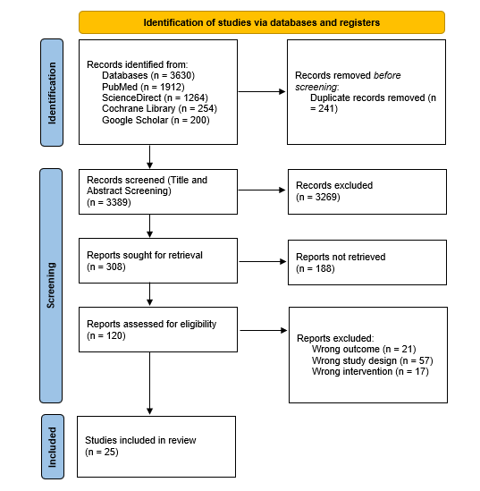
Figure 1: PRISMA flowchart showing the study selection process
Results of Data Extraction
A study descriptor table is shown in the Appendix (Table 1).
Results of quality appraisal
The quality appraisal of the included studies revealed a generally positive adherence to key methodological criteria, though variability exists among them. Out of the 25 studies reviewed, 9 studies demonstrated strong methodological quality by meeting all 10 appraisal items. Everson et al. (26), Feng et al. (27), Guo et al. (29), Meng et al. (33), Nakagawa et al. (34), Tajiri et al. (38), Tang et al. (39), Tokai et al. (41), Uema et al. (42), Waki et al. (43), Wang et al. (44), Yang et al. (45), and Yuan et al. (48) received "No" or "Unclear" ratings for whether they utilized consecutive or random patient samples and avoided case-control designs. Additionally, issues were identified regarding inappropriate exclusions, the interpretation of index test results without knowledge of the reference standard, and the clarity of threshold specifications. In contrast, all studies successfully met the criteria for items seven to ten, which assessed the reference standard's reliability and patient inclusion in the analysis. This is shown in Table 2 in the appendix.
Study characteristics: A summary
This paper included 25 studies, comprising 7 prospective studies, 17 retrospective studies, and 1 RCT. The total population across these studies was 21406 participants from various countries, including China, Japan, Taiwan, the USA, and India. The studies employed a variety of CAD algorithms, including Deep Neural Networks (DNN), Convolutional Neural Networks (CNN), SegNet, Deep Convolutional Neural Networks (DCNN), Big Transfer (BiT), and Fully Convolutional Networks.
Results of included studies: summary
Comparing CAD systems for NBI and WLI in detecting ESCC
Multiple studies have demonstrated the effectiveness of CAD systems across both NBI and WLI in identifying ESCC. Li et al. (32) found that their CAD system designed for non-magnified NBI (NM-NBI) outperformed a previously developed CAD-WLI system in terms of accuracy and specificity for detecting early-stage ESCC. They further suggested that optimal diagnostic outcomes could be achieved by combining both CAD-WLI and CAD-NBI systems for screening. Similarly, Cai et al. (25) introduced a deep neural network (DNN)-based CAD system for WLI, which demonstrated high accuracy and sensitivity in detecting early lesions that might otherwise have been overlooked by endoscopists.
Yuan et al. (47) reported that their AI system, when applied to WLI, exhibited superior sensitivity in detecting superficial ESCC confined to the epithelium compared to experienced endoscopists. This supports the growing role of AI systems in improving diagnostic accuracy for early-stage cancers. Ohmori et al. (35) explored AI's performance in detecting ESCC using both non-magnifying endoscopy (non-ME) and magnifying endoscopy (ME). They found that while the AI system showed high sensitivity using non-ME, it achieved greater accuracy in distinguishing between cancerous and noncancerous lesions when magnifying endoscopy was employed.
Assessing the impact of CAD systems on diagnostic accuracy, efficiency, and clinical workflow
Several studies have shown that CAD systems significantly enhance diagnostic accuracy when compared to human endoscopists. Nakagawa et al. (34) reported that their deep learning-based AI system performed on par with experienced endoscopists in assessing the invasion depth of superficial ESCC. Similarly, Shimamoto et al. (36) demonstrated that AI systems outperformed expert endoscopists in most diagnostic parameters when evaluating cancer invasion depth. The benefit of AI systems extends to less experienced clinicians as well. Meng et al. (33) found that CAD systems significantly improved detection rates, especially among novice endoscopists. Yang et al. (45) echoed these findings, reporting that AI-assisted diagnostics increased the accuracy of novices to levels comparable to experts, further highlighting the potential of CAD systems to bridge the experience gap in clinical practice.
In terms of clinical workflow, AI assistance has shown promising results in enhancing efficiency. Shiroma et al. (37) found that real-time AI integration during endoscopy significantly increased the sensitivity of endoscopists without hindering efficiency. Additionally, Yuan et al. (47) evaluated AI-assisted endoscopy in real clinical settings, reporting that AI had a neutral to positive effect on miss rates for superficial ESCC and precancerous lesions, demonstrating its value in improving detection while maintaining workflow efficiency. Waki et al. (43) similarly highlighted the utility of AI as a support tool, emphasizing its ability to maintain high sensitivity for detecting ESCC without compromising specificity, making it a valuable addition to clinical workflows.
The studies reviewed indicate strong consensus regarding the ability of CAD systems to enhance diagnostic accuracy and support endoscopists in the early detection of ESCC. Guo et al. (29) and Zhao et al. (49) demonstrated that their AI models achieved high sensitivity and specificity when applied to both endoscopic images and video datasets, reinforcing the broad applicability of AI systems in clinical settings. Tang et al. (39) and Tokai et al. (41) also found that AI systems performed well in real-time diagnostic scenarios, further validating the potential for these models to be integrated into routine clinical practice.
AI systems have been shown to effectively detect subtle lesions, such as superficial ESCC or lesions confined to the epithelium, which can be challenging for human observers. Studies by Feng et al. (27) and Fukuda et al. (28) confirmed that their AI systems were highly effective at detecting superficial ESCC, demonstrating robust diagnostic accuracy and generalizability across different clinical settings.
Table 2: Sensitivity and Specificity of AI-Assisted WLI and NBI for Detecting ESCC
Author (s) | Total number of cancer cases detected correctly  with AI+White light endoscopy (N) | Reported AI + WLI sensitivity | Reported AI + WLI specificity | Total number of cancer cases detected correctly  with AI+ Narrow Band imaging (N) | Reported AI + NBI sensitivity | Reported AI + NBI specificity
Cai et al. (25) | 89 | 97.80% | 85.40% | N/A | N/A | N/A
Everson et al. (26) | N/A | N/A | N/A | 63 | 93.70% | 92.40%
Feng et al. (27) | 129 | 99.23% | 84.66% | N/A | N/A | N/A
Fukuda et al. (28) | N/A | N/A | N/A | 39 | 91.10% | 51.50%
Guo et al. (29) | N/A | N/A | N/A | 1480 | 98.04% | 95.03%
Ikenoyama et al. (30) | 110 | 81.60% | N/A | 169 | 81.50% | N/A
Kumagai et al. (31) | 25 | 92.60% | 89.30% | N/A | N/A | N/A
Li et al. (32) | 131 | 98.50% | 83.10% | 167 | 91.00% | 96.70%
Meng et al. (33) | 83 | 84.10% | 90.90% | 85 | 88.40% | 93.40%
Nakagawa et al. (34) | NR | 90.10% | 95.80% | N/A | N/A | N/A
Ohmori et al. (35) | 47 | 90.00% | 76.00% | 51 | 100.00% | 63.00%
Shimamoto et al. (36) | NR | 70.80% | 94.90% | N/A | N/A | N/A
Shiroma et al. (37) | 15 | 75.00% | 30.00% | 11 | 55.00% | 80.00%
Tajiri et al. (38) | 71 | 85.50% | 75.00% | N/A | N/A | N/A
Tang et al. (39) | NR | 97.90% | 88.60% | N/A | N/A | N/A
Tani et al. (40) | N/A | N/A | N/A | 30 | 68.20% | 83.40%
Tokai et al. (41) | 112 | 93.30% | NR | 77 | 97.50% | NR
Uema et al. (42) | N/A | N/A | N/A | NR | 86.30% | NR
Waki et al. (43) | 49 | 77.80% | NR | 54 | 85.70% | NR
Wang et al. (44) | 39 | 94.70% | 76.50% | 53 | 97.40% | 76.60%
Yang et al. (45) | 74 | 90.90% | 85.00% | N/A | N/A | N/A
Yuan et al. (46) | NR | 89.50% | 73.70% | NR | 100.00% | 84.20%
Yuan et al. (47) | NR | NR | NR | NR | NR | NR
Yuan et al. (48) | N/A | N/A | N/A | NR | NR | NR
Zhao et al. (49) | N/A | N/A | N/A | NR | 87.00% | 84.10%

Meta-Analysis Results
Diagnostic Accuracy of AI-Assisted combined WLI and NBI
A total of 25 studies investigated the application of AI in endoscopic diagnosis of ESCC. 20 studies provided sufficient data for inclusion in the meta-analysis, with 6,550 patients comprising the validation cohort. The combined sensitivity and specificity were 92% (92–93%) and 92% (91–93%), respectively (Figs 2, 3 and 4).
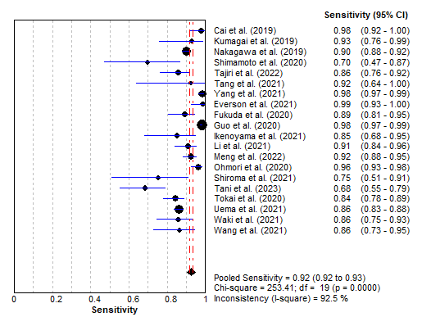
Figure 2: Forest plot showing sensitivity results of combined AI-assisted diagnosis of ESCC
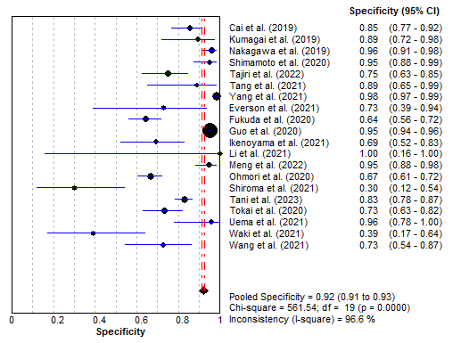
Figure 3: Forest plot showing specificity results of combined AI-assisted diagnosis of ESCC
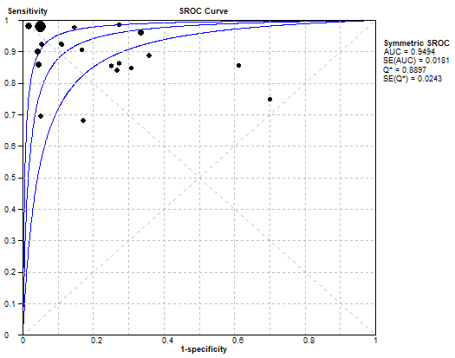
Figure 4: SROC of combined AI-assisted diagnosis of ESCC
Diagnostic Accuracy of AI-Assisted WLI
Out of the 20 studies included in the meta-analysis, 7 studies specifically examined AI-assisted WLI. These studies involved a validation cohort of 2,534 patients. The pooled sensitivity for AI-assisted WLI was 92% (91–94%), while the pooled specificity was 95% (94–96%) (Figs 5, 6, and 7).
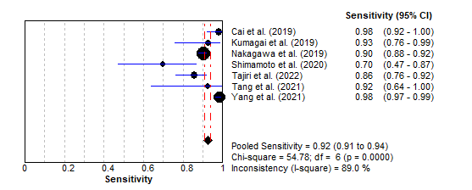
Figure 5: Forest plot of sensitivity of AI-assisted WLI
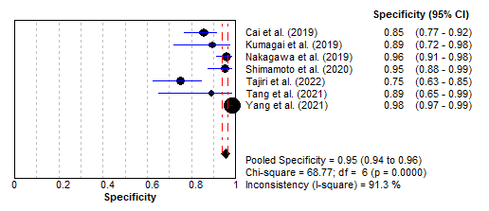
Figure 6: Forest plot of specificity of AI-assisted WLI
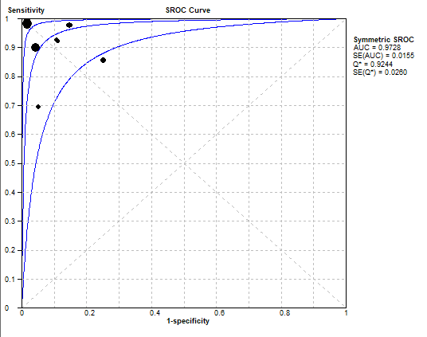
Figure 7: SROC curve AI-assisted WLI
Diagnostic Accuracy of AI-Assisted NBI
Five studies focused on AI-assisted NBI were included in the analysis, with a total of 3,133 patients in the validation cohort. The pooled sensitivity for AI-assisted NBI was 93% (92–94%), and the pooled specificity was 94% (93–94%) (Figs 8, 9, and 10).
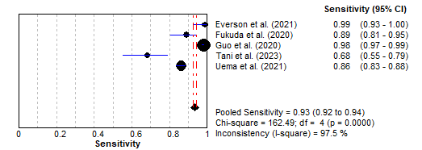
Figure 8: Forest plot of sensitivity of AI-assisted NBI
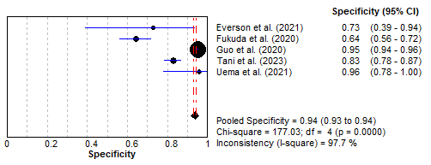
Figure 6: Forest plot of specificity of AI-assisted NBI
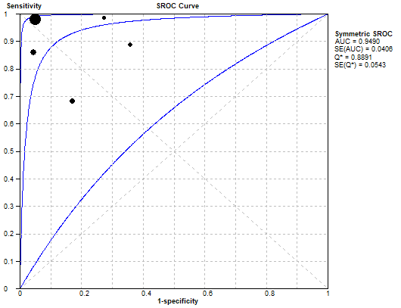
Figure 7: SROC curve AI-assisted NBI
Discussion
We compared AI systems designed for the detection of ESCC using NBI and WLI. The pooled sensitivity and specificity for both modalities were high, with NBI demonstrating a slight edge in sensitivity (93% for NBI vs. 92% for WLI). AI-assisted systems showed strong diagnostic accuracy, with sensitivity and specificity rates reaching as high as 95% in some cases. These findings suggest that AI can improve detection rates for ESCC in both NBI and WLI modalities, offering valuable assistance to endoscopists by reducing missed diagnoses and enhancing accuracy.
Our findings align with several key studies in the field. Cai et al. (25) introduced a deep neural network (DNN)--based CAD system for WLI, demonstrating high accuracy and sensitivity. This system helped endoscopists identify lesions that could have been overlooked, a result that mirrors our findings of AI systems improving detection capabilities. Similarly, the study by Everson et al. (26), which utilized a clinically interpretable CNN to predict histology in real time, showed that AI's diagnostic performance can rival that of expert endoscopists. This is consistent with our results, where AI-assisted systems performed comparably to experts, with sensitivity as high as 95% in some cases. Studies by Feng et al. (27) and Fukuda et al. (28) also demonstrated the high diagnostic accuracy and generalizability of AI systems for superficial esophageal squamous cell carcinoma (SESCC), reinforcing the potential of AI in clinical settings. Our findings showed similar robustness across both NBI and WLI, supporting the notion that AI systems offer valuable diagnostic support across various imaging modalities.
Furthermore, Guo et al. (29) reported high sensitivity and specificity in AI applications for both images and video datasets, a trend we observed in our analysis as well. This suggests that AI’s application is versatile and extends to dynamic imaging, improving real-time diagnostic performance during endoscopy. Li et al. (32) specifically compared AI systems for NBI and WLI, concluding that AI-assisted NBI exhibited greater accuracy and specificity. Our study confirmed this, with NBI showing slightly higher sensitivity and specificity than WLI. Their suggestion of combining both modalities for optimal diagnostic performance is supported by our findings, which underscore AI's effectiveness in both settings. The results by Ohmori et al. (35) and Shimamoto et al. (36) that showed no significant difference in performance between AI systems and expert endoscopists align with our findings. This suggests that AI systems can reliably perform as well as, or even better than, experienced clinicians, especially in detecting early-stage ESCC or superficial lesions. Several studies (37, 45, 47) also showed that AI assistance significantly improved the diagnostic accuracy of novice endoscopists. Our results similarly support the conclusion that AI systems can enhance detection, even for less experienced practitioners, and aid in reducing per-lesion miss rates, particularly with real-time video analysis.
The high sensitivity and specificity achieved by AI-assisted systems in both WLI and NBI suggest that these CAD systems can significantly improve the diagnostic accuracy of ESCC. With sensitivity rates as high as 93% and specificity reaching 95%, these AI systems help reduce the likelihood of missed lesions and minimize false-positive results. This improvement is particularly crucial in the context of endoscopic surveillance, where early and accurate detection of ESCC can have a significant impact on treatment outcomes. The integration of AI into routine endoscopic practice could provide endoscopists with an additional layer of diagnostic support, potentially leading to earlier detection and better patient prognosis. AI's ability to assist endoscopists, especially in identifying subtle lesions that may go unnoticed, enhances the overall reliability of the screening process and reduces operator dependency. Additionally, AI systems offer potential time-saving benefits by streamlining the diagnostic process. Their real-time analysis capabilities can lead to quicker identification of suspicious areas, thereby increasing procedural efficiency without compromising accuracy. The widespread use of AI systems could ultimately lead to improved clinical workflow, allowing endoscopists to focus more on treatment decisions rather than spending excessive time on lesion detection.
Limitations and Future Research
While our analysis indicates that AI-assisted systems for NBI and WLI offer high sensitivity and specificity, there are still limitations that need to be addressed. The differences in performance between AI-assisted NBI and WLI were minimal but notable, with NBI slightly outperforming WLI in sensitivity. However, the small margins observed in pooled results warrant further investigation. It is important to conduct more comprehensive studies to validate whether these differences translate into consistent clinical improvements when detecting ESCC in real-world settings. Future research should focus on exploring the conditions under which one modality may outperform the other and whether combining AI-assisted NBI and WLI could provide even greater diagnostic accuracy. Another limitation is the potential variation in AI system performance based on the training datasets used. The generalizability of AI systems across different clinical environments, endoscopists, and patient populations needs to be carefully assessed. Since our analysis mainly pooled results from different trials, variations in image quality, AI model architectures, and operator expertise could introduce heterogeneity that may affect the outcomes. Further multi-center trials with standardized protocols are necessary to evaluate the true potential and limitations of AI-assisted detection systems in clinical practice. Additionally, the long-term impact of integrating AI into endoscopic practice remains unclear. While AI systems show promise in improving diagnostic accuracy, future studies should also focus on evaluating their effects on clinical decision-making, patient outcomes, and the overall cost-effectiveness of AI-assisted endoscopy. Moreover, the potential for over-reliance on AI by less experienced endoscopists should be explored, as it may affect skill development in early lesion detection. Finally, ongoing technological improvements in AI systems, including advances in deep learning algorithms, image resolution, and real-time processing, will likely contribute to even higher diagnostic performance. Future research should aim to assess how these advancements can be optimized for clinical use, ensuring that AI systems continue to support, rather than replace, human expertise.
Conclusion
AI holds significant potential in enhancing diagnostic capabilities for esophageal malignancies, particularly in the early detection of ESCC. Our analysis demonstrates that AI-assisted systems for both NBI and WLI deliver high sensitivity and specificity, suggesting their usefulness in clinical practice. These systems not only reduce the likelihood of missed diagnoses but also offer the potential to streamline endoscopic workflows by providing real-time support. While the diagnostic performance of AI-assisted NBI slightly exceeds that of WLI, the small differences highlight the need for further research to determine the most effective applications of each modality in clinical settings.

References
1.
Uhlenhopp DJ, Then EO, Sunkara T, Gaduputi V. Epidemiology of esophageal cancer: update in global trends, etiology and risk factors. Clinical Journal of Gastroenterology. 2020 Sep 23;
2.
Yousefi MS, Sharifi-Esfahani M, Pourgholam-Amiji N, Afshar M, Sadeghi-Gandomani H, Otroshi O, et al. Esophageal cancer in the world: incidence, mortality and risk factors. Biomedical Research and Therapy [Internet]. 2018 Jul 28 [cited 2019 Nov 7];5(7):2504–17. Available from: http://www.bmrat.org/index.php/BMRAT/article/view/460
3.
Malhotra GK, Yanala U, Ravipati A, Follet M, Vijayakumar M, Are C. Global trends in esophageal cancer. Journal of Surgical Oncology. 2017 Mar 20;115(5):564–79.
4.
Reichenbach ZW, Murray MG, Saxena R, Farkas D, Karassik EG, Klochkova A, et al. Clinical and translational advances in esophageal squamous cell carcinoma. Advances in Cancer Research. 2019;95–135.
5.
Rai V, Abdo J, Agrawal DK. Biomarkers for Early Detection, Prognosis, and Therapeutics of Esophageal Cancers. International Journal of Molecular Sciences [Internet]. 2023 Jan 1;24(4):3316. Available from: https://www.mdpi.com/1422-0067/24/4/3316
6.
Abnet CC, Arnold M, Wei WQ. Epidemiology of Esophageal Squamous Cell Carcinoma. Gastroenterology [Internet]. 2018 Jan 1;154(2):360–73. Available from: https://www.ncbi.nlm.nih.gov/pmc/articles/PMC5836473/
7.
Simba H, Kuivaniemi H, Abnet CC, Tromp G, Vikash Sewram. Environmental and life-style risk factors for esophageal squamous cell carcinoma in Africa: a systematic review and meta-analysis. BMC Public Health. 2023 Sep 14;23(1).
8.
Conway E, Wu H, Tian L. Overview of Risk Factors for Esophageal Squamous Cell Carcinoma in China. Cancers. 2023 Nov 27;15(23):5604–4.
9.
Sun Y, Zhang T, Wu W, Zhao D, Zhang N, Cui Y, et al. Risk Factors Associated with Precancerous Lesions of Esophageal Squamous Cell Carcinoma: a Screening Study in a High Risk Chinese Population. Journal of Cancer. 2019;10(14):3284–90.
10.
Bang CS, Lee JJ, Baik GH. Computer-aided diagnosis of esophageal cancer and neoplasms in endoscopic images: a systematic review and meta-analysis of diagnostic test accuracy. Gastrointestinal Endoscopy. 2021 May;93(5):1006-1015.e13.
11.
CONTEDUCA V, SANSONNO D, INGRAVALLO G, MARANGI S, RUSSI S, LAULETTA G, et al. Barrett’s esophagus and esophageal cancer: An overview. International Journal of Oncology. 2012 May 17;41(2):414–24.
12.
Talukdar FR, di Pietro M, Secrier M, Moehler M, Goepfert K, Lima SSC, et al. Molecular landscape of esophageal cancer: implications for early detection and personalized therapy. Annals of the New York Academy of Sciences. 2018 Jun 19;1434(1):342–59.
13.
Alagappan M, Brown JRG, Mori Y, Berzin TM. Artificial intelligence in gastrointestinal endoscopy: The future is almost here. World Journal of Gastrointestinal Endoscopy. 2018 Oct 16;10(10):239–49.
14.
Sinagra E, Badalamenti M, Cabibbo G, Spadaccini M, Maselli R, Rossi F, et al. Use of artificial intelligence in improving adenoma detection rate during colonoscopy: Might both endoscopists and pathologists be further helped. 2020 Oct 21;26(39):5911–8.
15.
Liu Y. Artificial intelligence-assisted endoscopic detection of esophageal neoplasia in early stage: The next step? World Journal of Gastroenterology. 2021 Apr 14;27(14):1392–405.
16.
Guidozzi N, Menon N, Chidambaram S, Sheraz Rehan Markar. The role of artificial intelligence in the endoscopic diagnosis of esophageal cancer: a systematic review and meta-analysis. Diseases of the Esophagus. 2023 Jul 21;36(12).
17.
Pan Y, He L, Chen W, Yang Y. The current state of artificial intelligence in endoscopic diagnosis of early esophageal squamous cell carcinoma. Frontiers in Oncology. 2023 May 24;13.
18.
Dobashi A, Goda K, Yoshimura N, Ohya TR, Kato M, Sumiyama K, et al. Simplified criteria for diagnosing superficial esophageal squamous neoplasms using Narrow Band Imaging magnifying endoscopy. World Journal of Gastroenterology. 2016;22(41):9196.
19.
Mashimo H, Gordon SR, Singh SK. Advanced endoscopic imaging for detecting and guiding therapy of early neoplasias of the esophagus. Annals of the New York Academy of Sciences. 2020 Nov 12;1482(1):61–76.
20.
Tao Y, Fang L, Qin G, Xu Y, Zhang S, Zhang X, et al. Efficiency of endoscopic artificial intelligence in the diagnosis of early esophageal cancer. Thoracic Cancer. 2024 Apr 29;
21.
Zhang SM, Wang YJ, Zhang ST. Accuracy of artificial intelligence‐assisted detection of esophageal cancer and neoplasms on endoscopic images: A systematic review and meta‐analysis. Journal of Digestive Diseases. 2021 Jun;22(6):318–28.
22.
Page MJ, McKenzie JE, Bossuyt PM, Boutron I, Hoffmann TC, Mulrow CD, et al. The PRISMA 2020 statement: an Updated Guideline for Reporting Systematic Reviews. British Medical Journal [Internet]. 2021 Mar 29;372(71). Available from: https://www.bmj.com/content/372/bmj.n71
23.
Methley AM, Campbell S, Chew-Graham C, McNally R, Cheraghi-Sohi S. PICO, PICOS and SPIDER: a Comparison Study of Specificity and Sensitivity in Three Search Tools for Qualitative Systematic Reviews. BMC Health Services Research. 2014 Nov 21;14(1):1–10.
24.
Campbell JM, Klugar M, Ding S, Carmody DP, Hakonsen SJ, Jadotte YT, White S, Munn Z. Chapter 9: Diagnostic test accuracy systematic reviews. In: Aromataris E, Munn Z (Editors). JBI Manual for Evidence Synthesis. JBI, 2020
25.
Cai SL, Li B, Tan WM, Niu XJ, Yu HH, Yao LQ, et al. Using a deep learning system in endoscopy for screening of early esophageal squamous cell carcinoma (with video). Gastrointestinal Endoscopy. 2019 Nov;90(5):745-753.e2.
26.
Everson MA, Garcia-Peraza-Herrera L, Wang HP, Lee CT, Chung CS, Hsieh PH, et al. A clinically interpretable convolutional neural network for the real-time prediction of early squamous cell cancer of the esophagus: comparing diagnostic performance with a panel of expert European and Asian endoscopists. Gastrointestinal Endoscopy. 2021 Aug;94(2):273–81.
27.
Feng Y, Liang Y, Li P, Long Q, Song J, Li M, et al. Artificial intelligence assisted detection of superficial esophageal squamous cell carcinoma in white-light endoscopic images by using a generalized system. Discover Oncology. 2023 May 19;14(1).
28.
Fukuda H, Ishihara R, Kato Y, Matsunaga T, Nishida T, Yamada T, et al. Comparison of performances of artificial intelligence versus expert endoscopists for real-time assisted diagnosis of esophageal squamous cell carcinoma (with video). Gastrointestinal Endoscopy [Internet]. 2020 Oct 1;92(4):848–55. Available from: https://www.sciencedirect.com/science/article/pii/S0016510720343789
29.
Guo L, Xiao X, Wu C, Zeng X, Zhang YH, Du J, et al. Real-time automated diagnosis of precancerous lesions and early esophageal squamous cell carcinoma using a deep learning model (with videos). 2020 Jan 1;91(1):41–51.
30.
Ikenoyama Y, Yoshio T, Tokura J, Naito S, Namikawa K, Tokai Y, et al. Artificial intelligence diagnostic system predicts multiple Lugol-voiding lesions in the esophagus and patients at high risk for esophageal squamous cell carcinoma. Endoscopy. 2021 Feb 4;53(11):1105–13.
31.
Kumagai Y, Takubo K, Kawada K, Aoyama K, Endo Y, Ozawa T, et al. Diagnosis using deep-learning artificial intelligence based on the endocytoscopic observation of the esophagus. Esophagus. 2018 Dec 13;16(2):180–7.
32.
Li B, Cai SL, Yan B, Li J, Ayimukedisi Yalikong, Feng X, et al. Comparative study on artificial intelligence systems for detecting early esophageal squamous cell carcinoma between narrow-band and white-light imaging. 2021 Jan 21;27(3):281–93.
33.
Meng QQ, Gao Y, Lin H, Wang TJ, Zhang YR, Feng J, et al. Application of an artificial intelligence system for endoscopic diagnosis of superficial esophageal squamous cell carcinoma. World Journal of Gastroenterology. 2022 Oct 7;28(37):5483–93.
34.
Nakagawa K, Ishihara R, Aoyama K, Masayasu Ohmori, Nakahira H, Matsuura N, et al. Classification for invasion depth of esophageal squamous cell carcinoma using a deep neural network compared with experienced endoscopists. Gastrointestinal Endoscopy. 2019 Sep 1;90(3):407–14.
35.
Ohmori M, Ishihara R, Aoyama K, Nakagawa K, Hiroyoshi Iwagami, Matsuura N, et al. Endoscopic detection and differentiation of esophageal lesions using a deep neural network. 2020 Mar 25;91(2):301-309.e1.
36.
Shimamoto Y, Ishihara R, Kato Y, Shoji A, Inoue T, Katsunori Matsueda, et al. Real-time assessment of video images for esophageal squamous cell carcinoma invasion depth using artificial intelligence. Journal of Gastroenterology. 2020 Aug 10;55(11):1037–45.
37.
Shiroma S, Yoshio T, Kato Y, Horie Y, Namikawa K, Tokai Y, et al. Ability of artificial intelligence to detect T1 esophageal squamous cell carcinoma from endoscopic videos and the effects of real-time assistance. Scientific Reports [Internet]. 2021 Apr 8 [cited 2021 May 2];11(1). Available from: https://www.nature.com/articles/s41598-021-87405-6.pdf
38.
Tajiri A, Ishihara R, Kato Y, Inoue T, Katsunori Matsueda, Miyake M, et al. Utility of an artificial intelligence system for classification of esophageal lesions when simulating its clinical use. Scientific Reports. 2022 Apr 23;12(1).
39.
Tang D, Wang L, Jiang J, Liu Y, Ni M, Fu Y, et al. A Novel Deep Learning System for Diagnosing Early Esophageal Squamous Cell Carcinoma: A Multicenter Diagnostic Study. Clinical and Translational Gastroenterology [Internet]. 2021 Aug 1;12(8):e00393. Available from: https://journals.lww.com/ctg/fulltext/2021/08000/a_novel_deep_learning_system_for_diagnosing_early.7.aspx
40.
Tani Y, Ishihara R, Inoue T, Okubo Y, Kawakami Y, Katsunori Matsueda, et al. A single-center prospective study evaluating the usefulness of artificial intelligence for the diagnosis of esophageal squamous cell carcinoma in a real-time setting. BMC Gastroenterology. 2023 May 25;23(1).
41.
Tokai Y, Yoshio T, Aoyama K, Horie Y, Yoshimizu S, Horiuchi Y, et al. Application of artificial intelligence using convolutional neural networks in determining the invasion depth of esophageal squamous cell carcinoma. Esophagus. 2020 Jan 24;17(3):250–6.
42.
Uema R, Hayashi Y, Tashiro T, Saiki H, Kato M, Amano T, et al. Use of a convolutional neural network for classifying microvessels of superficial esophageal squamous cell carcinomas. Journal of Gastroenterology and Hepatology. 2021 Mar 10;36(8):2239–46.
43.
Waki K, Ishihara R, Kato Y, Shoji A, Inoue T, Kazuhiro Matsueda, et al. Usefulness of an artificial intelligence system for the detection of esophageal squamous cell carcinoma evaluated with videos simulating overlooking situation. Digestive Endoscopy. 2021 Jan 27;33(7):1101–9.
44.
Wang YK, Syu HY, Chen YH, Chung CS, Tseng YS, Ho SY, et al. Endoscopic Images by a Single-Shot Multibox Detector for the Identification of Early Cancerous Lesions in the Esophagus: A Pilot Study. Cancers. 2021 Jan 17;13(2):321.
45.
Yang X, Li Z, Shao X, Ji R, Qu J, Zheng M, et al. Real‐time artificial intelligence for endoscopic diagnosis of early esophageal squamous cell cancer (with video). Digestive Endoscopy. 2021 Jan 24;33(7):1075–84.
46.
Yuan X, Guo L, Liu W, Zeng X, Mou Y, Bai S, et al. Artificial intelligence for detecting superficial esophageal squamous cell carcinoma under multiple endoscopic imaging modalities: A multicenter study. Journal of Gastroenterology and Hepatology. 2021 Sep 17;37(1):169–78.
47.
Yuan XL, Liu W, Lin YX, Deng QY, Gao YP, Wan L, et al. Effect of an artificial intelligence-assisted system on endoscopic diagnosis of superficial oesophageal squamous cell carcinoma and precancerous lesions: a multicentre, tandem, double-blind, randomised controlled trial. The Lancet Gastroenterology & Hepatology. 2024 Jan 1;9(1):34–44.
48.
Yuan XL, Zeng XH, Liu W, Mou Y, Zhang WH, Zhou ZD, et al. Artificial intelligence for detecting and delineating the extent of superficial esophageal squamous cell carcinoma and precancerous lesions under narrow-band imaging (with video). Gastrointestinal Endoscopy. 2022 Dec 9;97(4):664-672.e4.
49.
Zhao YY, Xue DX, Wang YL, Zhang R, Sun B, Cai YP, et al. Computer-assisted diagnosis of early esophageal squamous cell carcinoma using narrow-band imaging magnifying endoscopy. Endoscopy. 2018 Nov 23;51(04):333–41.

Appendix
Table 1: Study Descriptor Table.
Author (s) | Year of articles | Study design  (Prospective-1, retrospective- 2, RCT- 3) | Population size (N)  [ number of people included] | Country | Type of CAD algorithm | Training on video-1  Training on images-2 | Total number  of images (N) | Total number  of images used for training (N) | Benign+/  Normal images (N) | Cancer on images (Yes-1  No-2) | Pathology confirmed (Yes-1, No-2)
Cai et al. (25) | 2019 | Prospective study (1) | 746 | China | DNN | Training on video (1) | 2,428 | 187 | 96 | Yes (1) | Yes (1)
Everson et al. (26) | 2021 | Prospective study (1) | 150 | Taiwan | CNN | Training on video (1) | 67,742 | 158 | 45 | Yes (1) | Yes (1)
Feng et al. (27) | 2023 | Prospective study (1) | 1283 | China | CNN | Training on image-2 | 7,358 | 5,892 | 1766 | Yes (1) | Yes (1)
Fukuda et al. (28) | 2020 | Retrospective study (2) | 144 | Japan | CNN | Training on video (1) | 25,910 | 144 | 50 | Yes (1) | Yes (1)
Guo et al. (29) | 2020 | Retrospective study (2) | 2123 | USA, China, and India | SegNet | Training on video (1) | 6,671 | 6,473 | 59 | Yes (1) | Yes (1)
Ikenoyama et al. (30) | 2021 | Retrospective study (2) | 72 | Japan | CNN | Training on image-2 | 6,634 | 3,898 | NR | No (2) | No (2)
Kumagai et al. (31) | 2019 | Prospective study (1) | 55 | Japan | CNN | Training on image-2 | 4,715 | 1,520 | 28 | Yes (1) | Yes (1)
Li et al. (32) | 2021 | Retrospective study (2) | 112 | China | CNN | Training on image-2 | 4,735 | 2,568 | 183 | Yes (1) | Yes (1)
Meng et al. (33) | 2022 | Retrospective study (2) | 323 | China | DCNN | Training on image-2 | 4,447 | 1,695 | 86 | Yes (1) | No (2)
Nakagawa et al. (34) | 2019 | Retrospective study (2) | 155 | Japan | CNN | Training on image-2 | 8660 non-ME and 5678 ME | 405 non-ME and 509 ME | NR | Yes (1) | No (2)
Ohmori et al. (35) | 2020 | Retrospective study (2) | 135 | Japan | CNN | Training on image-2 | 9591 non-ME and 7844 ME | 255 non-ME and 268 ME | 1128 non-ME and 691 ME | Yes (1) | Yes (1)
Shimamoto et al. (36) | 2020 | Retrospective study (2) | 102 | Japan | CNN | Training on video (1) | 23,977 | 102 | 102 | Yes (1) | No (2)
Shiroma et al. (37) | 2021 | Retrospective study (2) | 40 | Japan | CNN | Training on video (1) | 8,428 | 144 | 20 | Yes (1) | No (2)
Tajiri et al. (38) | 2022 | Retrospective study (2) | 130 | Japan | Big Transfer (BiT) | Training on video (1) | 25,048 | 147 | 64 | Yes (1) | Yes (1)
Tang et al. (39) | 2021 | Retrospective study (2) | 1078 | China | DCNN | Training on image-2 | 4,002 | 1,033 | 193 | Yes (1) | Yes (1)
Tani et al. (40) | 2023 | Prospective study (1) | 380 | Japan | Big Transfer (BiT) | Training on image-2 | 25,048 | 237 | 193 | Yes (1) | No (2)
Tokai et al. (41) | 2020 | Retrospective study (2) | 55 | Japan | CNN | Training on image-2 | 8,428 | 1,751 | 291 | Yes (1) | Yes (1)
Uema et al. (42) | 2021 | Retrospective study (2) | 336 | Japan | CNN | Training on image-2 | 2,551 | 1,777 | NR | Yes (1) | Yes (1)
Waki et al. (43) | 2021 | Retrospective study (2) | 100 | Japan | Trained neural network | Training on video (1) | 17,336 | 50 | 28 | Yes (1) | No (2)
Wang et al. (44) | 2021 | Prospective study (1) | 46 | Taiwan | CNN | Training on image-2 | 936 | 264 | 38 | Yes (1) | Yes (1)
Yang et al. (45) | 2021 | Retrospective study (2) | 268 | Japan | DCNN | Training on video (1) | 10,988 | 2,087 | 3698 | Yes (1) | No (2)
Yuan et al. (46) | 2022 | Retrospective study (2) | 396 | China | DCNN | Training on video (1) | 53,933 | 1,517 |  | Yes (1) | No (2)
Yuan et al. (47) | 2024 | RCT (3) | 11,846 | China | CNN | Training on image-2 | NR | NR | NR | Yes (1) | No (2)
Yuan et al. (48) | 2023 | Prospective study (1) | 1,112 | China | CNN | Training on video (1) |  |  |  | Yes (1) | No (2)
Zhao et al. (49) | 2019 | Retrospective study (2) | 219 | China | Fully convolutional network | Training on image-2 | 1,383 | 1,350 | NR | Yes (1) | No (2)

Table 2: Quality appraisal using the JBI checklist
Study | Item 1 | Item 2 | Item 3 | Item 4 | Item 5 | Item 6 | Item 7 | Item 8 | Item 9 | Item 10
Cai et al. (2019) | Yes | Yes | Yes | Yes | Yes | Yes | Yes | Yes | Yes | Yes
Everson et al. (2021) | No | Yes | Yes | Yes | Yes | Yes | Yes | Yes | Yes | Yes
Feng et al. (2023) | Yes | Unclear | Yes | Yes | Yes | Yes | Yes | Yes | Yes | Yes
Fukuda et al. (2020) | Yes | Yes | Yes | Yes | Yes | Yes | Yes | Yes | Yes | Yes
Guo et al. (2020) | No | Yes | Yes | Yes | Yes | Unclear | Yes | Yes | Yes | Yes
Ikenoyama et al. (2021) | Yes | Yes | Yes | Yes | Yes | Yes | Yes | Yes | Yes | Yes
Kumagai et al. (2019) | Yes | Yes | Yes | Yes | Yes | Yes | Yes | Yes | Yes | Yes
Li et al. (2021) | Yes | Yes | Yes | Yes | Yes | Yes | Yes | Yes | Yes | Yes
Meng et al. (2022) | Yes | Unclear | Yes | Unclear | Yes | Yes | Yes | Yes | Yes | Yes
Nakagawa et al. (2019) | Unclear | Yes | Yes | No | Yes | Yes | Yes | Yes | Yes | Yes
Ohmori et al. (2020) | Yes | Yes | Yes | Yes | Yes | Yes | Yes | Yes | Yes | Yes
Shimamoto et al. (2020) | Yes | Yes | Yes | No | Unclear | Yes | Yes | Yes | Yes | Yes
Shiroma et al. (2021) | Yes | Yes | Yes | No | Yes | Yes | Yes | Yes | Yes | Yes
Tajiri et al. (2022) | No | Yes | Yes | No | Yes | Yes | Yes | Yes | Yes | Yes
Tang et al. (2021) | Unclear | Yes | Yes | No | No | Yes | Yes | Yes | Yes | Yes
Tani et al. (2023) | Yes | Yes | Yes | Unclear | Yes | Yes | Yes | Yes | Yes | Yes
Tokai et al. (2020) | No | No | Yes | No | Yes | Yes | Yes | Yes | Yes | Yes
Uema et al. (2021) | No | Yes | Yes | No | Yes | Yes | Yes | Yes | Yes | Yes
Waki et al. (2021) | No | Yes | Yes | No | Unclear | Yes | Yes | Yes | Yes | Yes
Wang et al. (2021) | No | Yes | Yes | No | Yes | Yes | Yes | Yes | Yes | Yes
Yang et al. (2021) | Unclear | Yes | Yes | No | Yes | Yes | Yes | Yes | Yes | Yes
Yuan et al. (2022) | Yes | Yes | Yes | Yes | Yes | Yes | Yes | Yes | Yes | Yes
Yuan et al. (2024) | Yes | Yes | Yes | Yes | Yes | Yes | Yes | Yes | Yes | Yes
Yuan et al. (2023) | No | Yes | Unclear | No | Unclear | Yes | Yes | Yes | Yes | Yes
Zhao et al. (2019) | Yes | Yes | Yes | Yes | Yes | Yes | Yes | Yes | Yes | Yes
Item 1: Was a consecutive or random sample of patients enrolled? Item 2: Was a case control design avoided? Item 3: Did the study avoid inappropriate exclusions? Item 4: Were the index test results interpreted without knowledge of the results of the reference standard? Item 5: If a threshold was used, was it pre-specified? Item 6: Is the reference standard likely to correctly classify the target condition? Item 7: Were the reference standard results interpreted without knowledge of the results of the index test? Item 8: Was there an appropriate interval between index test and reference standard? Item 9: Did all patients receive the same reference standard? Item 10: Were all patients included in the analysis?

